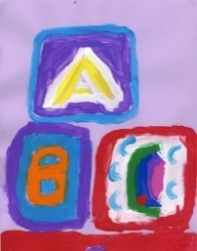
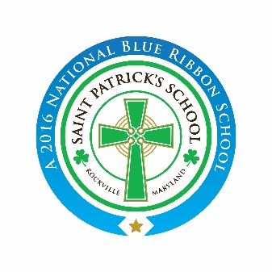
St. Patrick’s Catholic School
Pre-Kindergarten (4+) Program
2019-2020 Application
Application Fee $ 50.00

Student Information
Name: __________________________________________________________________ M____ F____
Last First Middle

Preferred Name:____________________________ Date of Birth: __________________________

Address: ____________________________________________________________________________
Number & Street City, Sate & Zip Code
Phone Number: ___________________________ Family E-mail _______________________________

Religion: _________________________________ Parish: ________________________________

Has your child ever been evaluated for developmental, speech, academic, or behavioral concerns? ____
If yes, please provide additional information or specialists’ contact information.

Parent Information
Father’s Name: _____________________________________ Religion: ________________________

Cell Phone: _________________________________________ Occupation: ______________________

Mother’s Name: _____________________________________ Religion: _________________________

Cell Phone: _________________________________________ Occupation: ______________________

Children in Family:
________________________________________ ______________________________________
Name Date of Birth Name Date of Birth

________________________________________ ______________________________________
Name Date of Birth Name Date of Birth

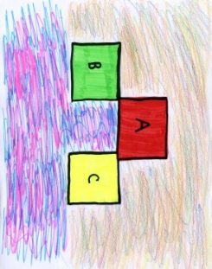
Please mark the appropriate class:
____ Monday through Friday 8:15 a.m. - 2:50 p.m.
____ Monday through Friday 8:15 a.m. - 1:00 p.m.

